MY CLIMATE SUPERPOWERS ACTION PLAN
Every person has unique skills and talents (or Superpowers) they can use to help address the challenge of climate change – including young people. Take the quiz at climatesuperpowers.org/quiz to find out yours, then answer the questions below.
Circle your main Climate Superpower below:
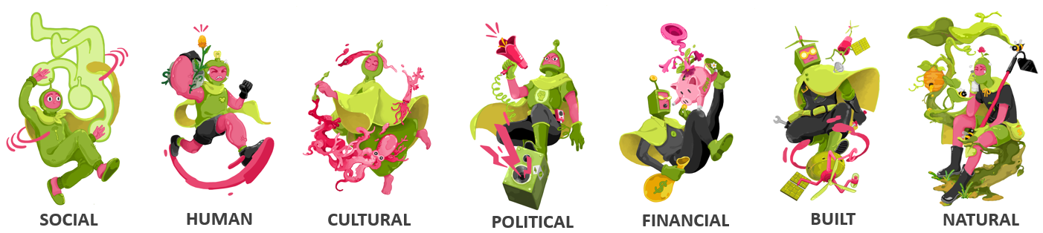
Explain what your main Climate Superpower means to you. What strengths and talents does it involve?

We can use these strengths, talents, and Superpowers to take actions big or small to help address climate change and positively impact the world around us. These actions can involve learning more, making small changes to our everyday lives, looking after ourselves, or working to transform our society. You can find many examples on climatesuperpowers.org.
Identify a specific action for the categories below that you would like to take to help address climate change using your climate superpowers. If you have time: Note down which superpowers you would use for each action – e.g. maybe you’ll be using your strongest superpower plus a couple of your other superpowers, too!
LEARNING ABOUT CLIMATE CHANGE | EVERYDAY LIFE
SELF-CARE | TRANSFORMING SOCIETY

